Policies_Verifying Agency Billed Policy_Instance43_29-May-2018_04-39-17_AM_SingleSignOn.png

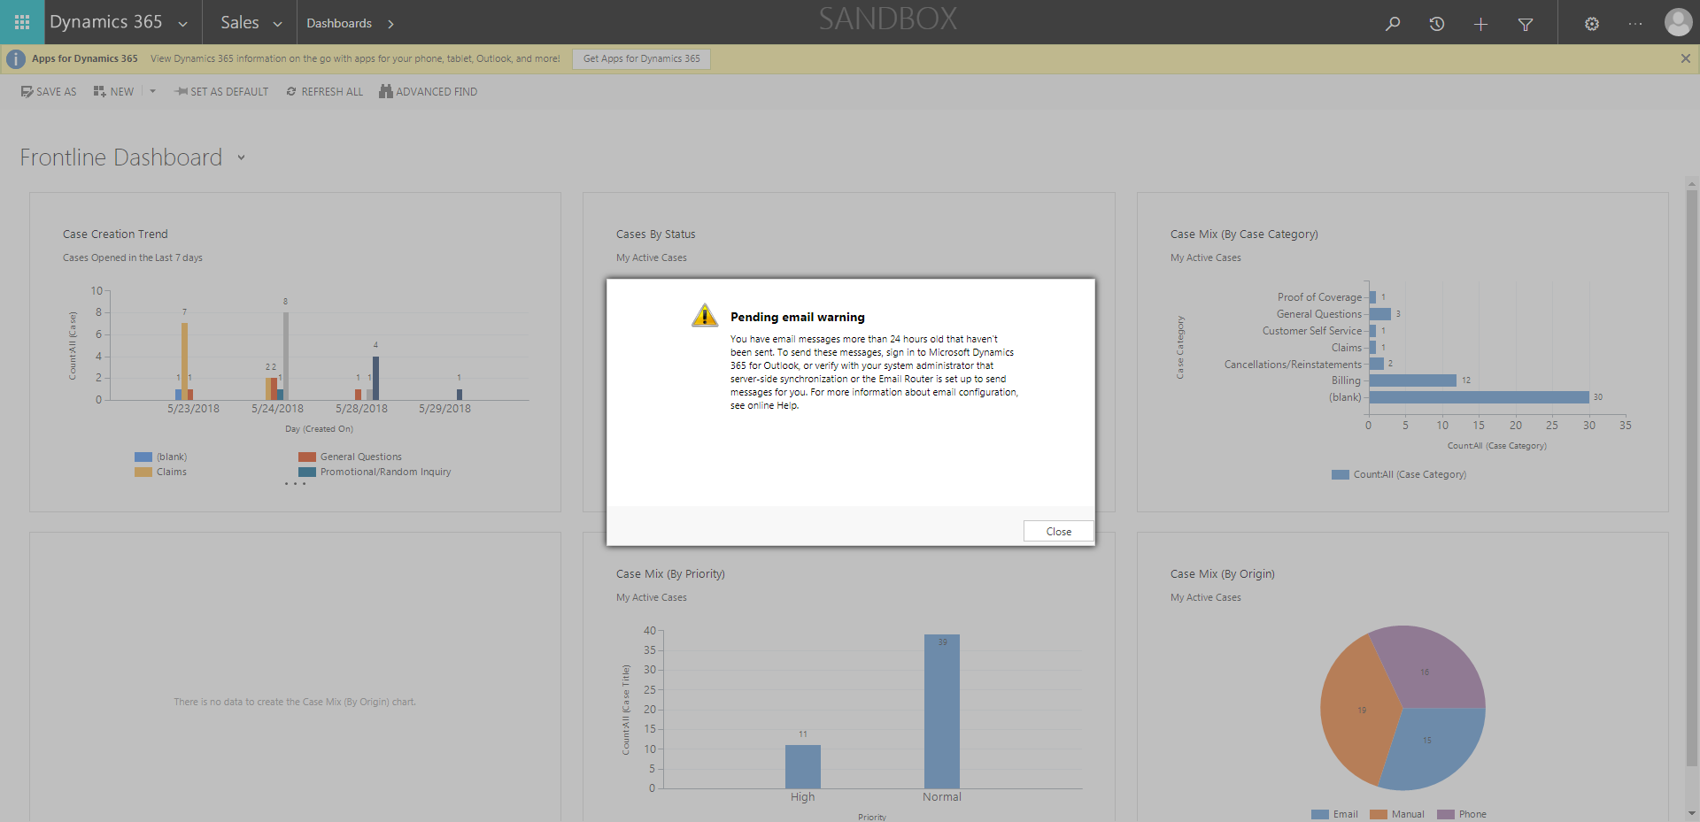

Policies_Verifying Agency Billed Policy_Instance43_29-May-2018_04-38-33_AM_MouseClickActiononStaleElement.png

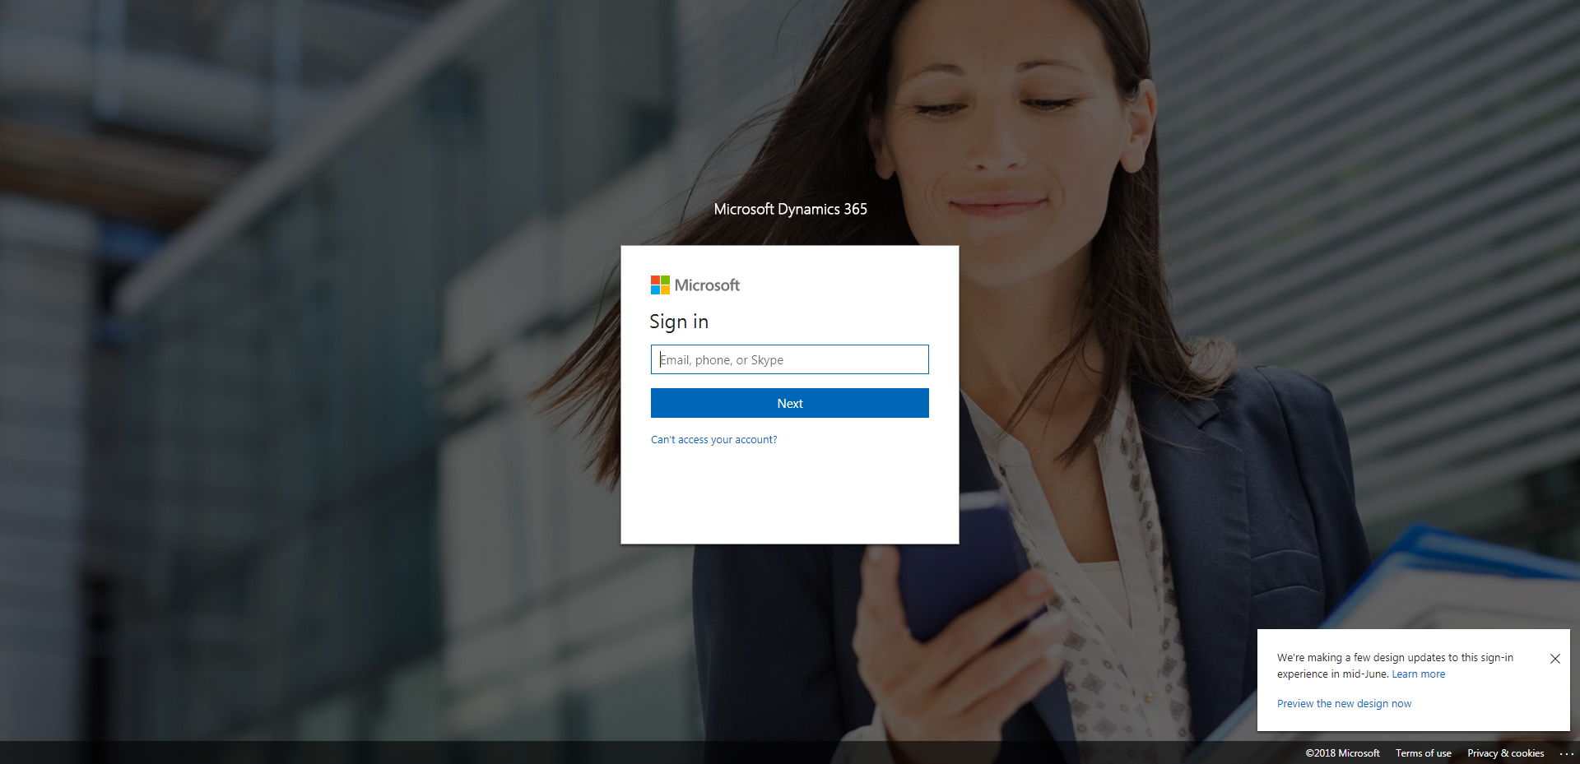

Policies_Verifying Agency Billed Policy_Instance43_29-May-2018_04-38-37_AM_MouseClickActiononStaleElement.png

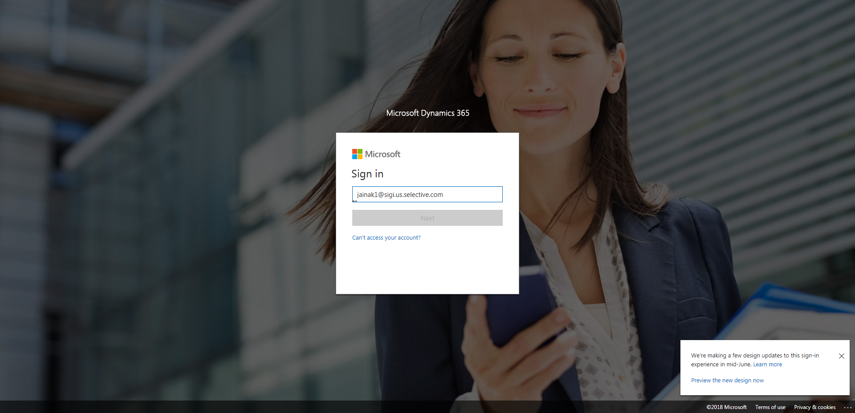

Policies_Verifying Agency Billed Policy_Instance43_29-May-2018_04-39-44_AM_ValidationofAgencyBilledPolicy.png

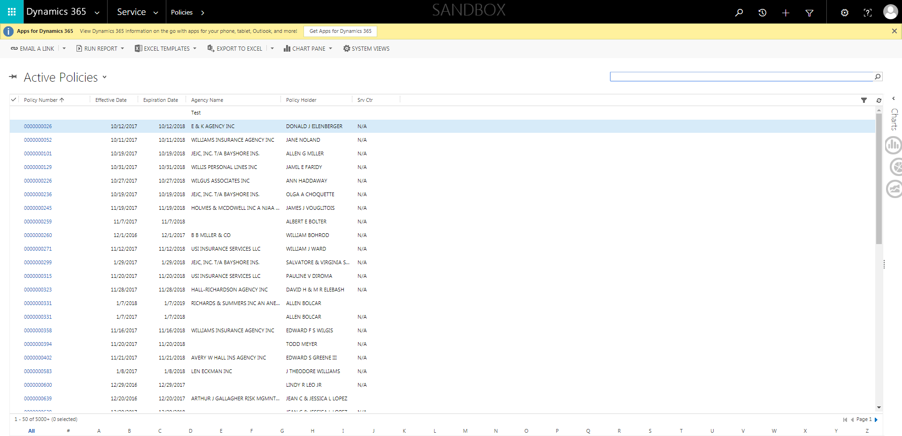

Policies_Verifying Agency Billed Policy_Instance43_29-May-2018_04-38-35_AM_EnterTextAction.png

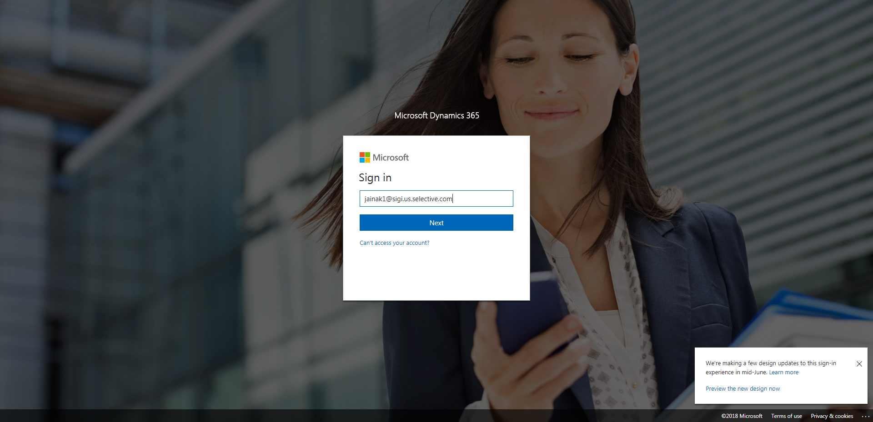

Policies_Verifying Agency Billed Policy_Instance43_29-May-2018_04-39-22_AM_SingleSignOn.png

